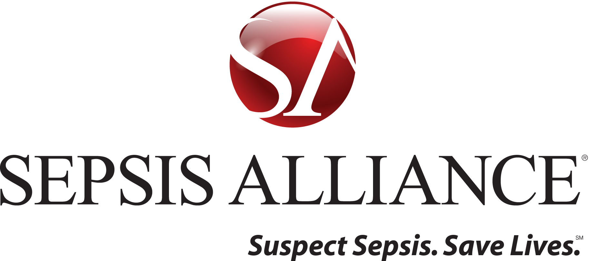

[Date]

[Address]

Dear [Name,]

Sepsis, the body’s overwhelming and life-threatening response to infection, kills over 250,000 Americans each year. Despite being the third leading cause of death, only 55% of US adults have heard of sepsis.

Sepsis Alliance is the nation’s leading non-profit organization working to save lives and reduce suffering by raising awareness of sepsis as a medical emergency. Early detection and treatment of sepsis is the key to life or death in many cases, and we believe that raising awareness of the symptoms of sepsis can save lives.

Many community members support the work of Sepsis Alliance by hosting fundraisers. Now is your chance to support the cause by making a donation to [event name.]

Sepsis Alliance is a 501 (c)(3) organization. All donations made directly to Sepsis Alliance are deductible to the fullest extent of the law and are acknowledged with a tax receipt. Tax ID 38-3110993.

If you have any questions please contact me at sstark@sepsis.org or 619-232-0300.

Best regards,

Savannah Stark
Operations and Development Manager

